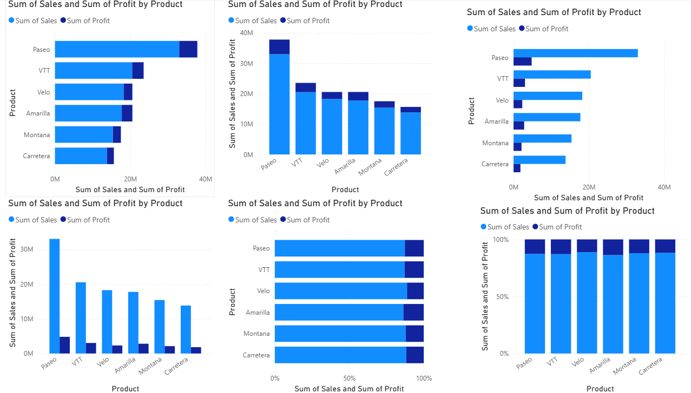

In Power BI Clustered column/Bar chart is the most common choice .

X-Axis -> Products

Y-Axis -> Values (Sales and Profit as separate series)

Because,

* It shows sales and Profit **Side by Side** for each product.
* Easy to Compare both metrics across all Products.
* Works best when you have a moderate number of products (say 5-20).